Nama : CHAYA SAUSAN AFRAH

NIM : 200220007

KELAS : REG. PAGI

1. JOIN TABLE

SELECT * FROM kategori Join barang ON kategori.id_kategori = barang.id_kategori

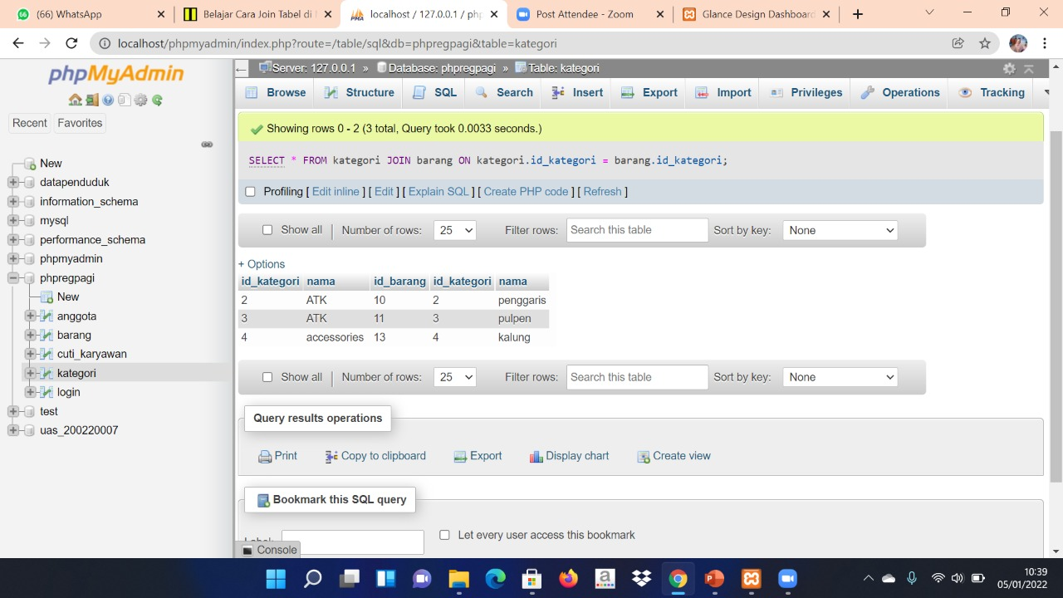

1. FUNGSI COUNT

SELECT nama, COUNT(nama) AS jumlah FROM kategori GROUP BY nama;

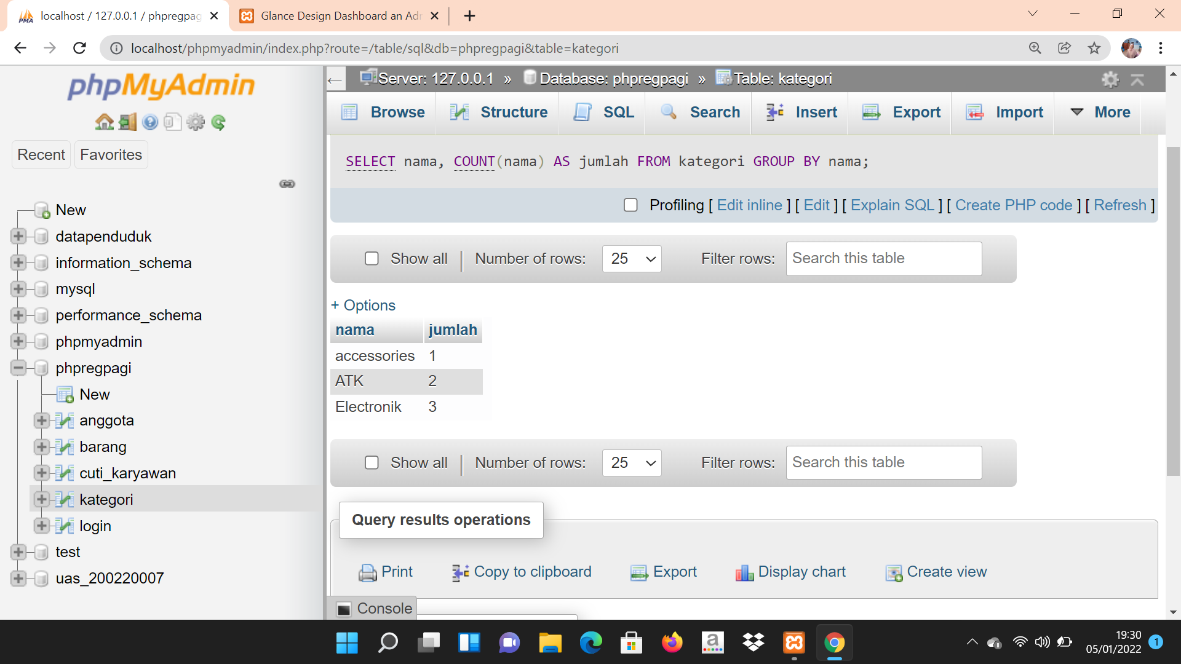

SELECT nama, COUNT(nama) AS jumlah FROM barang GROUP BY nama;

